1. **Designaforminthatdisplaycitynameincomboboxcontrolonselectionof city. (Use OLEDB database connectivity)**

usingSystem;

using System.Collections.Generic; usingSystem.ComponentModel;using System.Data;

using System.Drawing; usingSystem.Linq;using System.Text;using System.Windows.Forms;

namespace ass_4_1

{

publicpartialclassForm1:Form

{

publicForm1()

{

InitializeComponent();

}

privatevoidForm1_Load(objectsender,EventArgse)

{

// TODO: This line of code loads datainto the '_city_mdbDataSet.city' table. You can move, or remove it, as needed. this.cityTableAdapter.Fill(this._city_mdbDataSet.city);

}

privatevoidcomboBox1_SelectedIndexChanged(objectsender,EventArgse)

{

MessageBox.Show("youselected"+comboBox1.SelectedValue.ToString()+" city "); }

}

}

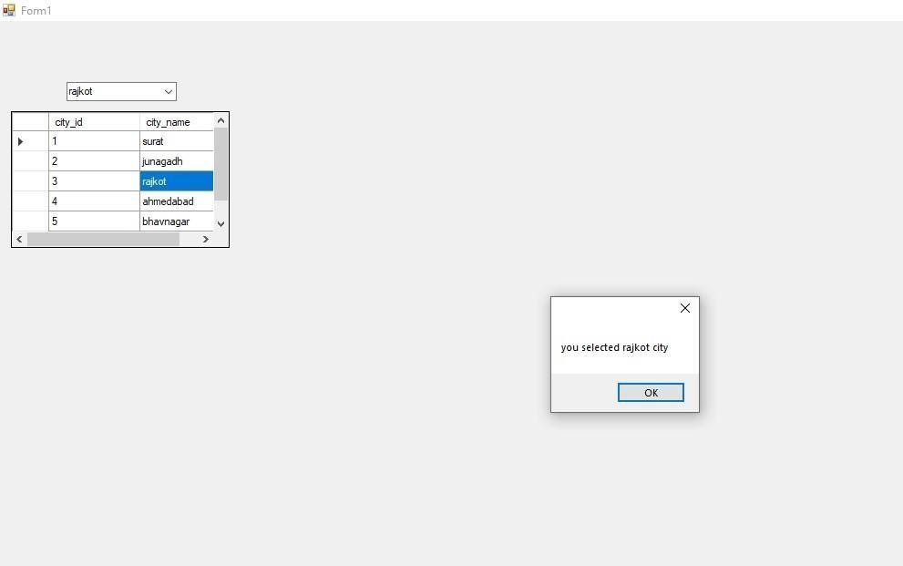

1. **WriteaProgramtodevelopaDatabaseApplicationwithRecord**

**Navigation(next,previous,first,last)forBookstable(BookID,BookName,Qty, UnitPrice,TotalPrice).**

usingSystem;

using System.Collections.Generic; usingSystem.ComponentModel;using System.Data;

using System.Drawing; usingSystem.Linq;using System.Text;using System.Windows.Forms; using System.Data.OleDb;

namespaceass4_2

{

publicpartialclassForm1:Form

{

Form1()

Int32 pos, lastrec; Stringconnstr,query; OleDbConnection cn; OleDbCommand cmd; OleDbDataAdapter da; DataSet ds;

public

{

InitializeComponent();

}

privatevoidForm1_Load(objectsender,EventArgse)

{

connstr="Provider=Microsoft.ACE.OLEDB.12.0;Data Source=C:\\Users\\BAPS\\Documents\\c#\\BOOk4_1.mdb.accdb";

cn=newOleDbConnection(connstr);

query = "select * from BOOK1"; cmd = new OleDbCommand(query, cn); da=new OleDbDataAdapter(cmd); ds =

new DataSet(); da.Fill(ds);

lastrec=ds.Tables[0].Rows.Count-1; pos

=0;

fillTextbox(pos); fillgridview();

}

voidfillTextbox(Int32pos)

{

Book_id.Text = ds.Tables[0].Rows[pos][0].ToString(); Book_name.Text=ds.Tables[0].Rows[pos][1].ToString();

qty.Text = ds.Tables[0].Rows[pos][2].ToString(); Unit_price.Text = ds.Tables[0].Rows[pos][3].ToString(); total_price.Text=ds.Tables[0].Rows[pos][4].ToString();

}

voidfillgridview()

{

query="select*fromBOOK1"; cmd=newOleDbCommand(query,cn);

da=newOleDbDataAdapter(cmd); da.Fill(ds);

dataGridView1.DataSource=ds.Tables[0]; dataGridView1.Refresh();

}

privatevoidbutton1_Click(objectsender,EventArgse)

{

pos = 0; fillTextbox(pos);

}

privatevoidbutton3_Click(objectsender,EventArgse)

{

if(pos<=0)

pos=0; else

pos-= 1;

fillTextbox(pos);

}

privatevoidbutton4_Click(objectsender,EventArgse)

{

if(pos>=lastrec) pos = lastrec;

else

pos += 1; fillTextbox(pos);

}

privatevoidbutton2_Click(objectsender,EventArgse)

{

pos=lastrec; fillTextbox(pos);

}

}

}

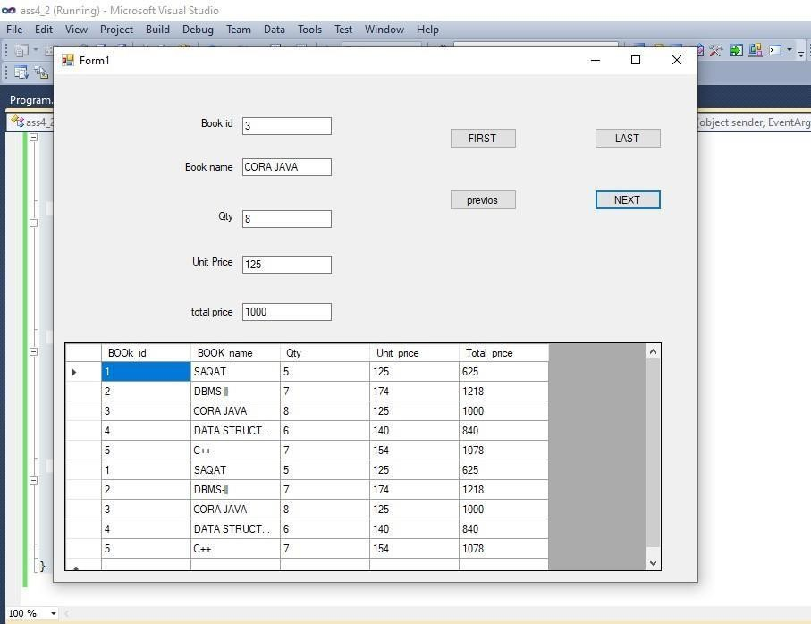

1. **CreateTABLECity(CityCode,CityName).Provideinsert,update,selectand delete operation using database connectivity.**

usingSystem;

using System.Collections.Generic; usingSystem.ComponentModel;using System.Data;

using System.Drawing; usingSystem.Linq;using System.Text;using System.Windows.Forms; using System.Data.OleDb;

namespace ASS4_3

{

publicpartialclassForm1:Form

{

Form1()

Int32 pos, lastrec; Stringconnstr,query; OleDbConnection cn; OleDbCommand cmd; OleDbDataAdapter da; DataSet ds;

public

{

InitializeComponent();

}

privatevoidForm1_Load(objectsender,EventArgse)

{

//TODO:Thislineofcodeloadsdataintothe'_city_mdbDataSet.city'table. You can move, or remove it, as needed. this.cityTableAdapter.Fill(this._city_mdbDataSet.city);

// TODO: This line of code loads data into the '_city_mdbDataSet.city' table. You can move, or remove it, as needed. this.cityTableAdapter.Fill(this._city_mdbDataSet.city); connstr

= "Provider=Microsoft.ACE.OLEDB.12.0;Data Source=C:\\Users\\BAPS\\Documents\\city.mdb.accdb"; cn = new OleDbConnection(connstr);

query="select*fromcity"; cmd=

new OleDbCommand(query, cn); da=new OleDbDataAdapter(cmd); ds = new DataSet(); da.Fill(ds);

lastrec=ds.Tables[0].Rows.Count-1; pos = 0;

fillTextbox(pos); fillgridview();

}

voidfillTextbox(Int32pos)

{

city_id.Text=ds.Tables[0].Rows[pos][0].ToString(); city_name.Text = ds.Tables[0].Rows[pos][1].ToString();

} void

fillgridview()

{

query="select*fromcity"; cmd = new OleDbCommand(query, cn);

da=newOleDbDataAdapter(cmd); da.Fill(ds);

dataGridView1.DataSource=ds.Tables[0]; dataGridView1.Refresh();

}

privatevoidbutton1_Click_1(objectsender,

EventArgse)

{

pos=0;

fillTextbox(pos);

}

privatevoidbutton3_Click_1(objectsender,EventArgse)

{

if(pos<=0)

pos=0; else

pos-= 1;

fillTextbox(pos);

}

privatevoidbutton4_Click_1(objectsender,EventArgse)

{ if(pos

>= lastrec) pos=lastrec; else

pos+=1; fillTextbox(pos);

}

privatevoidbutton2_Click_1(objectsender,EventArgse)

{

pos=lastrec; fillTextbox(pos);

}

}}

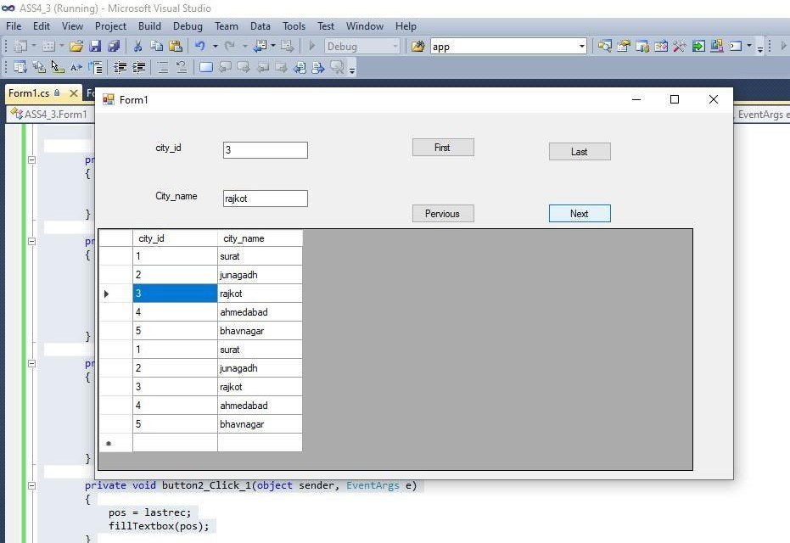

1. **WriteaprogramtocreateatableEmployeewiththefollowingfields: Eno**

**Ename Salary**

**Designation**

**DesignaformwhichperformsSelect,Insert,UpdateandDeleteoperations on the table Employee.**

usingSystem;

using System.Collections.Generic; usingSystem.ComponentModel;using System.Data;

using System.Drawing; usingSystem.Linq;using System.Text;using System.Windows.Forms; using System.Data.OleDb; namespace ASS4_4

{

publicpartialclassForm1:Form

{

Form1()

Int32 pos, lastrec; Stringconnstr,query; OleDbConnection cn; OleDbCommand cmd; OleDbDataAdapter da; DataSet ds;

public

{

InitializeComponent();

}

privatevoidForm1_Load(objectsender,EventArgse)

{

connstr="Provider=Microsoft.ACE.OLEDB.12.0;Data Source=C:\\Users\\BAPS\\Documents\\emp.mdb.accdb";cn

=newOleDbConnection(connstr); query = "select * from emp";

cmd=newOleDbCommand(query,cn); da = new OleDbDataAdapter(cmd);

ds=newDataSet(); da.Fill(ds);

lastrec=ds.Tables[0].Rows.Count-1; pos = 0;

fillTextbox(pos); fillgridview();

}

voidfillTextbox(Int32pos)

{

Eno.Text= ds.Tables[0].Rows[pos][0].ToString(); Ename.Text= ds.Tables[0].Rows[pos][1].ToString(); Salary.Text= ds.Tables[0].Rows[pos][2].ToString(); Designation.Text=ds.Tables[0].Rows[pos][3].ToString();

} voidfillgridview()

{ query="select*

from emp"; cmd=new OleDbCommand(query, cn);

da=newOleDbDataAdapter(cmd);

ds = new DataSet(); da.Fill(ds); dataGridView1.DataSource = ds.Tables[0];

dataGridView1.Refresh();

}

privatevoidbutton1_Click(objectsender,EventArgse)

{

query="select*fromempwhereEno="+ Eno.Text; int eno =

Int32.Parse(Eno.Text); cmd=new OleDbCommand(query,cn); cn.Open(); cmd.ExecuteReader(); cn.Close();

eno=eno-1;

pos=eno; fillTextbox(pos);

}

privatevoidbutton2_Click(objectsender,EventArgse)

{

query=query= "insertintoempvalues("+Eno.Text+",'"+ Ename.Text + "','"+ Salary.Text + "', '"+ Designation.Text + "')";

cmd=new OleDbCommand(query,cn); cn.Open(); cmd.ExecuteNonQuery();

cn.Close();

MessageBox.Show("recordinsertedsuccessfully ");

fillgridview();

}

privatevoidbutton3_Click(objectsender,EventArgse)

{

query=query= "updateemp setname='"+Ename.Text+"',salary='"+ Salary.Text + "', designation = '"+ Designation.Text + "' where Eno = "+ Eno.Text;

cmd=new OleDbCommand(query,cn); cn.Open(); cmd.ExecuteNonQuery();

cn.Close();

MessageBox.Show("reordupdateedsuccessfully..."); fillgridview();

}

privatevoidbutton4_Click(objectsender,EventArgse)

{

query=query= "deletefromempwhereEno="+Eno.Text+""; cmd = new

OleDbCommand(query,cn);

cn.Open(); cmd.ExecuteNonQuery(); cn.Close();

MessageBox.Show("recorddeletedsuccesfull ");

fillgridview();

}

}

}

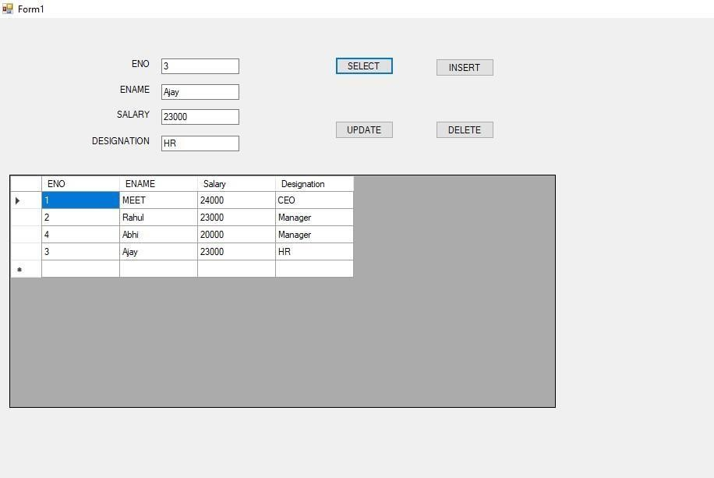

1. **DesignafollowingtableinAccess.Tablename=Book(Bookcode,**

**Bookpublisher,Bookauther,Bookpage,Bprice).DesignFormthatDisplay Above detail. Provide Add, Update, Delete, Next, first, last, pervious**

**functionalities.Provideconnectivityusingcoding.**

usingSystem;

using System.Collections.Generic; usingSystem.ComponentModel;using System.Data;

using System.Drawing; usingSystem.Linq;using System.Text;using System.Windows.Forms; using System.Data.OleDb;

namespace ass4_5

{

publicpartialclassForm1:Form

{

Int32 pos, lastrec; Stringconnstr,query; OleDbConnection cn; OleDbCommand cmd; OleDbDataAdapter da;

DataSet ds; public Form1()

{

InitializeComponent();

}

privatevoidForm1_Load(objectsender,EventArgse)

{

connstr = "Provider=Microsoft.ACE.OLEDB.12.0;Data Source=C:\\Users\\BAPS\\Documents\\BOOK2.mdb.accdb"; cn = new OleDbConnection(connstr);

query="select*fromBOOK2"; cmd

=newOleDbCommand(query,cn); da

= new OleDbDataAdapter(cmd); ds= new DataSet(); da.Fill(ds);

lastrec=ds.Tables[0].Rows.Count-1;

pos=0; fillTextbox(pos);

fillgridview();

}

voidfillTextbox(Int32pos)

{

BCODE.Text = ds.Tables[0].Rows[pos][0].ToString(); BPUBLISHER.Text=ds.Tables[0].Rows[pos][1].ToString(); Bauther.Text = ds.Tables[0].Rows[pos][2].ToString(); Bpage.Text = ds.Tables[0].Rows[pos][3].ToString(); Bprice.Text = ds.Tables[0].Rows[pos][4].ToString();

}

voidfillgridview()

{

query="select*fromBOOK2"; cmd = new OleDbCommand(query, cn);

da=newOleDbDataAdapter(cmd); da.Fill(ds);

dataGridView1.DataSource=ds.Tables[0]; dataGridView1.Refresh();

}

privatevoidbutton5_Click(objectsender,EventArgse)

{

pos=0; fillTextbox(pos);

}

privatevoidbutton7_Click(objectsender,EventArgse)

{

if(pos<= 0)

pos=0; else

pos -= 1; fillTextbox(pos);

} privatevoidbutton4_Click(objectsender, EventArgs e)

{

if(pos>=lastrec) pos = lastrec;

else

pos += 1; fillTextbox(pos);

}

privatevoidbutton6_Click(objectsender,EventArgse)

{

pos=lastrec; fillTextbox(pos);

}

privatevoidbutton1_Click(objectsender,EventArgse)

{

query = "insert into BOOK2 values ("+ BCODE.Text + " , '"+ BPUBLISHER.Text+"','"+Bauther.Text+"','"+Bpage.Text+"','"+Bprice.Text

+"')"; cmd=new

OleDbCommand(query,cn); cn.Open(); cmd.ExecuteNonQuery();

cn.Close();

MessageBox.Show("recordinsertedsuccessfully ");

fillgridview();

}

privatevoidbutton3_Click(objectsender,

EventArgse)

{

query="deletefromBOOK2whereBCODE='"+BCODE.Text+"'"; cmd = new OleDbCommand(query, cn); cn.Open(); cmd.ExecuteNonQuery();

cn.Close();

MessageBox.Show("recorddeletedsuccessfully ");

fillgridview(); }

privatevoidbutton2_Click(objectsender,EventArgse)

{

query="updateBOOK2setBPUBLISHER='"+BPUBLISHER.Text+"',BAUTHER='"

+Bauther.Text+ "',Bpage='"+Bpage.Text+"',Bprice='"+Bprice.Text+"'where BCODE="+ BCODE.Text;

cmd=newOleDbCommand(query,cn);

cn.Open(); cmd.ExecuteNonQuery();

cn.Close();

MessageBox.Show("recoedupdatedsuccessfully ");

fillgridview();

}

}

}

